- INTRODUCTION
Power electronics is an enabling technology that achieves conversion of electric power from one form to another, using a combination of high-power semiconductor devices and passive components— chiefly transformers, inductors, and capacitors. The input and output may be alternating current (ac) or direct current (dc) and may differ in magnitude and frequency. The conversion sometimes involves multiple stages with two or more converters connected in a cascade. The end goals of a power electronic converter are to achieve high efficiency of conversion, minimize size and weight, and achieve desired regulation of the output. Power electronic converters can be classified into four different types on the basis of input and output, dc-dc, dc-ac, ac-dc, and ac-ac, named with the first part referring to the input and the second to the output. The diode bridge rectifier is the front end for most low-power converters. It converts line frequency ac (e.g., from a wall outlet) to an unregulated dc voltage, and the process is commonly called rectification. In a dc-dc converter, both the input and the output are dc, and in the simplest case the output voltage needs to be regulated in presence of variation in load current and changes in the input voltage. A computer power supply has a diode bridge front end followed by a dc-dc converter, the combination of which converts line frequency ac voltage to several regulated dc voltages. Electronic ballasts for compact fluorescent lamps consist of a line frequency rectifier followed by a dc to high-frequency ac converter (frequency range of 20 to 100 kHz) whose output is connected to a resonant tank circuit that includes the load. In an adjustable speed motor drive application, the input is a 3-phase ac supply, and the output is a 3-phase ac whose magnitude and frequency are varied for optimum steady-state operation and dynamic requirements of the drive.
Fig.1.1. Application of power electronic converters
Cascaded bridge configuration is again classified into 2 types 1) Cascaded Half Bridge 2) Cascaded Full Bridge or Cascaded H-Bridge

1.1 Harmonics
Harmonics are periodic sinusoidal distortions of the supply voltage or load current caused by non-linear loads. Harmonics are measured in integer multiples of the fundamental supply frequency. Using Fourier series analysis the individual frequency components of the distorted waveform can be described in terms of the harmonic order, magnitude and phase of each component. The electricity is produced and distributed in its fundamental form as 50hz in India.
A harmonics is defined as the content of signal who’s frequency is integer multiple of the system fundamental frequency. Due to harmonic effect the sinusoidal waveform is no longer have stand and it become non-sinusoidal or complex waveform. The complex waveform consists of a fundamental wave of 50 Hz and a number of other sinusoidal waves whose frequencies are integral multiple of fundamental wave like 2f(100hz). 3f (150 Hz), 4f (200 Hz) etc. Wave having frequency of 2f, 4f, 6f etc are called the even harmonics and those having frequency of 3f, 5f, 7f etc are called as odd harmonics. When fundamental frequency is super imposed with high-level harmonics, it results into complex wave and which is non sinusoidal. When non-linear load draws current, that current passes through all of the impedance that is between the load and the system source (See Figure 4). As a result of the current flow, harmonic voltages are produced by impedance in the system for each harmonic. These voltages sum and when added to the nominal voltage produce voltage distortion. The magnitude of the voltage distortion depends on the source impedance and the harmonic voltages produced. If the source impedance is low then the voltage distortion will be low. If a significant portion of the load becomes non-linear (harmonic currents increase) and/or when a resonant condition prevails (system impedance increases), the voltage can increase dramatically.

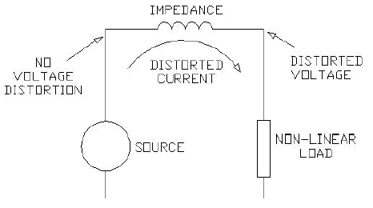
Fig: 1.2 Distorted-current induced voltage distortion
1.2 Total harmonic Distortion (Distortion factor)
The THD is defined as the ratio of the rms value of the harmonic components to the rms value of the fundamental component and usually expressed in percent. This index is used to measure the deviation of a periodic wave form containing harmonics from a perfect sine wave. For a perfect sine wave at fundamental frequency, the THD is zero.
Or
1.3 Total demand distortion
The total demand distortion (TDD) is the total harmonic current distortion defined as
Where I_{L} is the maximum demand load at fundamental frequency at the point of common coupling (PCC) calculated as the average of previous twelve months.

- INTRODUCTION TO POWER ELECTRONICS
Power Electronics is a field which combines Power (electric power), Electronics and Control systems. Power engineering deals with the static and rotating power equipment for the generation, transmission and distribution of electric power. Electronics deals with the study of solid state semiconductor power devices and circuits for Power conversion to meet the desired control objectives (to control the output voltage and output power).
Power electronics may be defined as the subject of applications of solid state power semiconductor devices (Thyristors) for the control and conversion of electric power.
Power electronics deals with the study and design of Thyristorised power controllers for variety of application like Heat control, Light/Illumination control, Motor control – AC/DC motor drives used in industries, High voltage power supplies, Vehicle propulsion systems, High voltage direct current (HVDC) transmission.

2.1 Power Electronic Applications
- Commercial Applications
Heating Systems Ventilating, Air Conditioners, Central Refrigeration, Lighting, Computers and Office equipments, Uninterruptible Power Supplies (UPS), Elevators, and Emergency Lamps.

- Domestic Applications
Cooking Equipments, Lighting, Heating, Air Conditioners, Refrigerators & Freezers, Personal Computers, Entertainment Equipments, UPS.

- Industrial Applications
Pumps, compressors, blowers and fans. Machine tools, arc furnaces, induction furnaces, lighting control circuits, industrial lasers, induction heating, welding equipments.

- Aerospace Applications
Space shuttle power Supply systems, satellite power systems, aircraft power systems.

- Tele Communications
Battery chargers, power supplies (DC and UPS), mobile cell phone battery chargers.
- Transportation
Traction control of electric vehicles, battery chargers for electric vehicles, electric locomotives, street cars, trolley buses, automobile electronics including engine controls.
- Utility Systems
High voltage DC transmission (HVDC), static VAR compensation (SVC), Alternative energy sources (wind, photovoltaic), fuel cells, energy storage systems, induced draft fans and boiler feed water pumps.

2.2 Differences Between Electronics And Power Electronics
This question can be answered in number of ways. The simplest way to say all the electronics devices which deals with power are covered in Power Electronics. There are devices which you do use in general purpose electronics like: Diode, BJT, MFETs etc. You will find these devices in electronics & power electronics both. The devices used in Power electronics may differ in term of construction & behavior from those used in electronics. There are types of devices which you will find only IN PE, ex: IGBT.
- The only difference is that power devices (e.g. MOSFETs) are made to handle much larger power requirements.
- Ordinary devices are low current and low voltage devices.
- Power devices are high current and/or high voltage devices.
2.3 Power Converters
A power converter is an electrical or electro-mechanical device for converting electrical energy. It may be converting AC to or from DC, or the voltage or frequency, or some combination of these.
Amongst the many devices that are used for this purpose are:
- Rectifier
- Inverter
- DC - DC converter
- AC - AC converter

2.3.1 Ac - Dc Converter (Rectifier)
A rectifier is an electrical device that converts alternating current (AC), which periodically reverses direction, to direct current (DC), which is in only one direction, a process known as rectification.
Rectifiers have many uses including as components of power supplies and as detectors of radio signals. Rectifiers may be made of solid state diodes, vacuum tube diodes, mercury arc valves, and other components.
2.3.2 Dc - Ac Converter (Inverter)
An inverter is an electrical device that converts direct current (DC) to alternating current (AC); the converted AC can be at any required voltage and frequency with the use of appropriate transformers, switching, and control circuits.
Solid-state inverters have no moving parts and are used in a wide range of applications, from small switching power supplies in computers, to large electric utility high-voltage direct current applications that transport bulk power. Inverters are commonly used to supply AC power from DC sources such as solar panels or batteries.
2.3.3 Dc - Dc Converter (Choppers)
A dc chopper is a dc-to-dc voltage converter. It is a static switching electrical appliance that in one Electrical conversion, changes an input fixed dc voltage to an adjustable dc output voltage without Inductive or capacitive intermediate energy storage. The name chopper is connected with the fact that the output voltage is a ‘chopped up’ quasi-rectangular version of the input dc voltage.
2.3.4 Ac - Ac Converter
An AC/AC converter converts an AC waveform such as the mains supply, to another AC waveform, where the output voltage and frequency can be set arbitrarily.
AC/AC converters can be categorized into
- Cycloconverters
- Matrix Converters

  - Power Electronic Switches
In electronics, a switch is an electrical component that can break an electrical circuit, interrupting the current or diverting it from one conductor to another.
A power electronic switch integrates a combination of power electronic components or power semiconductors and a driver for the actively switchable power semiconductors. The internal functional correlations and interactions of this integrated system determine several
Diodes
In electronics, a diode is a type of two-terminal electronic component with a nonlinear current–voltage characteristic. A semiconductor diode, the most common type today, is a crystalline piece of semiconductor material connected to two electrical terminals. A vacuum tube diode (now rarely used except in some high-power technologies) is a vacuum tube with two electrodes: a plate and a cathode.
The most common function of a diode is to allow an electric current to pass in one direction (called the diode's forward direction), while blocking current in the opposite direction (the reverse direction). Thus, the diode can be thought of as an electronic version of a check valve. This unidirectional behavior is called rectification, and is used to convert alternating current to direct current, and to extract modulation from radio signals in radio receivers.
However, diodes can have more complicated behavior than this simple on–off action. Semiconductor diodes do not begin conducting electricity until a certain threshold voltage is present in the forward direction (a state in which the diode is said to be forward biased). The voltage drop across a forward biased diode varies only a little with the current, and is a function of temperature; this effect can be used as a temperature sensor or voltage reference.
Semiconductor diodes have nonlinear electrical characteristics, which can be tailored by varying the construction of their P–N junction. These are exploited in special purpose diodes that perform many different functions.
Diodes were the first semiconductor electronic devices. The discovery of crystals' rectifying abilities was made by German physicist Ferdinand Braun in 1874. The first semiconductor diodes, called cat's whisker diodes, developed around 1906, were made of mineral crystals such as galena. Today most diodes are made of silicon, but other semiconductors such as germanium are sometimes used.
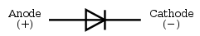
Fig 2.1 : Diode
A modern semiconductor diode is made of a crystal of semiconductor like silicon that has impurities added to it to create a region on one side that contains negative charge carriers (electrons), called n-type semiconductor, and a region on the other side that contains positive charge carriers (holes), called p-type semiconductor. The diode's terminals are attached to each of these regions. The boundary within the crystal between these two regions, called a PN junction, is where the action of the diode takes place. The crystal conducts a current of electrons in a direction from the N-type side (called the cathode) to the P-type side (called the anode), but not in the opposite direction. However, conventional current flows from anode to cathode in the direction of the arrow (opposite to the electron flow, since electrons have negative charge).
Another type of semiconductor diode, the Scotty diode, is formed from the contact between a metal and a semiconductor rather than by a p–n junction.
Thyristors
A thyristor is a solid-state semiconductor device with four layers of alternating n and p-type material. They act as bistable switches, conducting when their gate receives a current pulse, and continue to conduct while they are forward biased (that is, while the voltage across the device is not reversed).
Some sources define silicon controlled rectifiers and thyristors as synonymous.
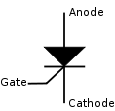
Fig 2.2 : Circuit symbol for a Thyristor
Function
The thyristor is a four-layer, three terminal semiconducting device, with each layer consisting of alternately N-type or P-type material, for example P-N-P-N. The main terminals, labeled anode and cathode, are across the full four layers, and the control terminal, called the gate, is attached to p-type material near to the cathode. (A variant called an SCS—Silicon Controlled Switch—brings all four layers out to terminals.) The operation of a thyristor can be understood in terms of a pair of tightly coupled bipolar junction transistors, arranged to cause the self-latching action:
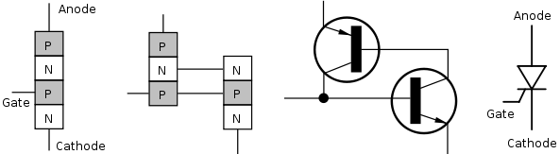
Fig 2.3: Structure on the physical and electronic level, and the thyristor symbol.
Thyristors have three states:
- Reverse blocking mode — Voltage is applied in the direction that would be blocked by a diode
- Forward blocking mode — Voltage is applied in the direction that would cause a diode to conduct, but the thyristor has not yet been triggered into conduction
- Forward conducting mode — The thyristor has been triggered into conduction and will remain conducting until the forward current drops below a threshold value known as the "holding current"

Insulated Gate Bipolar Transistor (IGBT)
The insulated-gate bipolar transistor or IGBT is a three-terminal power semiconductor device, noted for high efficiency and fast switching. It switches electric power in many modern appliances: electric cars, variable speed refrigerators, air-conditioners, and even stereo systems with digital amplifiers. Since it is designed to rapidly turn on and off, amplifiers that use it often synthesize complex waveforms with pulse width modulation and low-pass filters.
The IGBT combines the simple gate-drive characteristics of the MOSFETs with the high-current and low–saturation-voltage capability of bipolar transistors by combining an isolated-gate FET for the control input, and a bipolar power transistor as a switch, in a single device. The IGBT is used in medium- to high-power applications such as switched-mode power supply, traction motor control and induction heating. Large IGBT modules typically consist of many devices in parallel and can have very high current handling capabilities in the order of hundreds of amps with blocking voltages of 6,000 V.
Equivalent Circuit
An examination of reveals that if we move vertically up from collector to emitter. We come across p+, n- , p layer s. Thus, IGBT can be thought of as the combination of MOSFET and p+ n⁻ p layer s. Thus, IGBT can be thought of as the combination of MOSFET and p⁺ n⁻ p transistor Q1 .Here Rd is resistance offered by n – drift region. Approximate equivalent circuit of an IGBT.
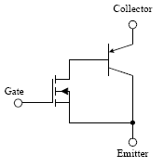
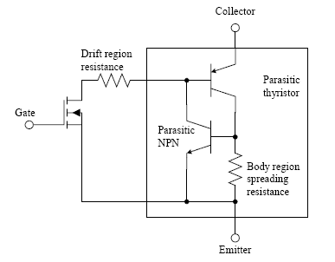
Fig 2.4 :Equivalent circuit
MOSFET
The metal–oxide–semiconductor field-effect transistor (MOSFET, MOS-FET, or MOS FET) is a transistor used for amplifying or switching electronic signals. The basic principle of this kind of transistor was first proposed by Julius Edgar Lilienfeld in 1925. In MOSFETs, a voltage on the oxide-insulated gate electrode can induce a conducting channel between the two other contacts called source and drain. The channel can be of n-type or p-type (see article on semiconductor devices), and is accordingly called an nMOSFET or a pMOSFET (also commonly nMOS, pMOS). It is by far the most common transistor in both digital and analog circuits, though the bipolar junction transistor was at one time much more common.
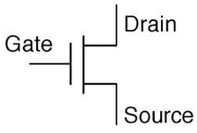
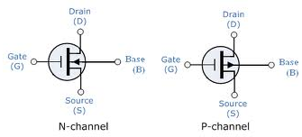

The 'metal' in the name is now often a misnomer because the previously metal gate material is now often a layer of polysilicon (polycrystalline silicon). Aluminium had been the gate material until the mid 1970s, when polysilicon became dominant, due to its capability to form self-aligned gates. Metallic gates are regaining popularity, since it is difficult to increase the speed of operation of transistors without metal gates.
MOSFET Operation
A metal–oxide–semiconductor field-effect transistor (MOSFET) is based on the modulation of charge concentration by a MOS capacitance between a body electrode and a gate electrode located above the body and insulated from all other device regions by a gate dielectric layer which in the case of a MOSFET is an oxide, such as silicon dioxide. If dielectrics other than an oxide such as silicon dioxide (often referred to as oxide) are employed the device may be referred to as a metal–insulator–semiconductor FET (MISFET). Compared to the MOS capacitor, the MOSFET includes two additional terminals (source and drain), each connected to individual highly doped regions that are separated by the body region. These regions can be either p or n type, but they must both be of the same type, and of opposite type to the body region. The source and drain (unlike the body) are highly doped as signified by a '+' sign after the type of doping.
If the MOSFET is an n-channel or NMOS FET, then the source and drain are 'n+' regions and the body is a 'p' region. As described above, with sufficient gate voltage, holes from the body are driven away from the gate, forming an inversion layer or n-channel at the interface between the p region and the oxide. This conducting channel extends between the source and the drain, and current is conducted through it when a voltage is applied between source and drain. Increasing the voltage on the gate leads to a higher electron density in the inversion layer and therefore increases the current flow between the source and drain.
For gate voltages below the threshold value, the channel is lightly populated, and only a very small sub threshold leakage current can flow between the source and the drain.
If the MOSFET is a p-channel or PMOS FET, then the source and drain are 'p+' regions and the body is a 'n' region. When a negative gate-source voltage (positive source-gate) is applied, it creates a p-channel at the surface of the n region, analogous to the n-channel case, but with opposite polarities of charges and voltages.
When a voltage less negative than the threshold value (a negative voltage for p-channel) is applied between gate and source, the channel disappears and only a very small sub threshold current can flow between the source and the drain.
The source is so named because it is the s layer. If the channel region between the gate dielectric and a Buried Oxide (BOX) region is very thin, the very thin channel region is referred to as an Ultra Thin Channel (UTC) region with the source and drain regions formed on either side thereof in and/or above the thin semiconductor layer. Alternatively, the device may comprise a Semiconductor On Insulator (SEMOI) device in which semiconductors other than silicon are employed. Many alternative semiconductor materials may be employed.

2.5: Pulse Width Modulation (PWM)
Pulse Width Modulation (PWM) is the most effective means to achieve constant voltage battery charging by switching the solar system controller’s power devices. When in PWM regulation, the current from the solar array tapers according to the battery’s condition and recharging needs Consider a waveform such as this: it is a voltage switching between 0v and 12v. It is fairly obvious that, since the voltage is at 12v for exactly as long as it is at 0v, then a 'suitable device' connected to its output will see the average voltage and think it is being fed 6v - exactly half of 12v. So by varying the width of the positive pulse - we can vary the 'average' voltage.
Similarly, if the switches keep the voltage at 12 for 3 times as long as at 0v, the average will be 3/4 of 12v - or 9v, as shown below and if the output pulse of 12v lasts only 25% of the overall time, then the average is
By varying - or 'modulating' - the time that the output is at 12v (i.e. the width of the positive pulse) we can alter the average voltage. So we are doing 'pulse width modulation'. I said earlier that the output had to feed 'a suitable device'. A radio would not work from this: the radio would see 12v then 0v, and would probably not work properly. However a device such as a motor will respond to the average, so PWM is a natural for motor control.
Pulse Width Modulator
So, how do we generate a PWM waveform? It's actually very easy, there are circuits available in the TEC site. First you generate a triangle waveform as shown in the diagram below. You compare this with a d.c voltage, which you adjust to control the ratio of on to off time that you require. When the triangle is above the 'demand' voltage, the output goes high. When the triangle is below the demand voltage, the
When the demand speed it in the middle (A) you get a 50:50 output, as in black. Half the time the output is high and half the time it is low. Fortunately, there is an IC (Integrated circuit) called a comparator: these come usually 4 sections in a single package. One can be used as the oscillator to produce the triangular waveform and another to do the comparing, so a complete oscillator and modulator can be done with half an IC and maybe 7 other bits.
The triangle waveform, which has approximately equal rise and fall slopes, is one of the commonest used, but you can use a saw tooth (where the voltage falls quickly and rinses slowly). You could use other waveforms and the exact linearity (how good the rise and fall are) is not too important.
Traditional solenoid driver electronics rely on linear control, which is the application of a constant voltage across a resistance to produce an output current that is directly proportional to the voltage. Feedback can be used to achieve an output that matches exactly the control signal. However, this scheme dissipates a lot of power as heat, and it is therefore very inefficient.
A more efficient technique employs pulse width modulation (PWM) to produce the constant current through the coil. A PWM signal is not constant. Rather, the signal is on for part of its period, and off for the rest. The duty cycle, D, refers to the percentage of the period for which the signal is on. The duty cycle can be anywhere from 0, the signal is always off, to 1, where the signal is constantly on. A 50% D results in a perfect square wave. (Figure 1)
A solenoid is a length of wire wound in a coil. Because of this configuration, the solenoid has, in addition to its resistance, R, a certain inductance, L. When a voltage, V, is applied across an inductive element, the current, I, produced in that element does not jump up to its constant value, but gradually rises to its maximum over a period of time called the rise time (Figure 2). Conversely, I does not disappear instantaneously, even if V is removed abruptly, but decreases back to zero in the same amount of time as the rise time.
Therefore, when a low frequency PWM voltage is applied across a solenoid, the current through it will be increasing and decreasing as V turns on and off. If D is shorter than the rise time, I will never achieve its maximum value, and will be discontinuous since it will go back to zero during V’s off period (Figure 3).* In contrast, if D is larger than the rise time, I will never fall back to zero, so it will be continuous, and have a DC average value. The current will not be constant, however, but will have a ripple.
At high frequencies, V turns on and off very quickly, regardless of D, such that the current does not have time to decrease very far before the voltage is turned back on. The resulting current through the solenoid is therefore considered to be constant. By adjusting the D, the amount of output current can be controlled. With a small D, the current will not have much time to rise before the high frequency PWM voltage takes effect and the current stays constant. With a large D, the current will be able to rise higher before it becomes constant.
Why The PWM Frequency Is Important
The PWM is a large amplitude digital signal that swings from one voltage extreme to the other. And, this wide voltage swing takes a lot of filtering to smooth out. When the PWM frequency is close to the frequency of the waveform that you are generating, then any PWM filter will also smooth out your generated waveform and drastically reduce its amplitude. So, a good rule of thumb is to keep the PWM frequency much higher than the frequency of any waveform you generate.
Finally, filtering pulses is not just about the pulse frequency but about the duty cycle and how much energy is in the pulse. The same filter will do better on a low or high duty cycle pulse compared to a 50% duty cycle pulse. Because the wider pulse has more time to integrate to a stable filter voltage and the smaller pulse has less time to disturb it the inspiration was a request to control the speed of a large positive displacement fuel pump. The pump was sized to allow full power of a boosted engine in excess of 600 Hp.
At idle or highway cruise, this same engine needs far less fuel yet the pump still normally supplies the same amount of fuel. As a result the fuel gets recycled back to the fuel tank, unnecessarily heating the fuel. This PWM controller circuit is intended to run the pump at a low speed setting during low power and allow full pump speed when needed at high engine power levels.
2.6: PWM Controller Features
This controller offers a basic “Hi Speed” and “Low Speed” setting and has the option to use a “Progressive” increase between Low and Hi speed. Low Speed is set with a trim pot inside the controller box. Normally when installing the controller, this speed will be set depending on the minimum speed/load needed for the motor. Normally the controller keeps the motor at this Lo Speed except when Progressive is used and when Hi Speed is commanded (see below). Low Speed can vary anywhere from 0% PWM to 100%.
Progressive control is commanded by a 0-5 volt input signal. This starts to increase PWM% from the low speed setting as the 0-5 volt signal climbs. This signal can be generated from a throttle position sensor, a Mass Air Flow sensor, a Manifold Absolute Pressure sensor or any other way the user wants to create a 0-5 volt signal. This function could be set to increase fuel pump power as turbo boost starts to climb (MAP sensor). Or, if controlling a water injection pump, Low Speed could be set at zero PWM% and as the TPS signal climbs it could increase PWM%, effectively increasing water flow to the engine as engine load increases.
This controller could even be used as a secondary injector driver (several injectors could be driven in a batch mode, hi impedance only), with Progressive control (0-100%) you could control their output for fuel or water with the 0-5 volt signal.
Progressive control adds enormous flexibility to the use of this controller. Hi Speed is that same as hard wiring the motor to a steady 12 volt DC source. The controller is providing 100% PWM, steady 12 volt DC power. Hi Speed is selected three different ways on this controller: 1) Hi Speed is automatically selected for about one second when power goes on. This gives the motor full torque at the start. If needed this time can be increased ( the value of C1 would need to be increased). 2) High Speed can also be selected by applying 12 volts to the High Speed signal wire. This gives Hi Speed regardless of the Progressive signal.

2.6.1: Sinusoidal Pulse Width Modulation
In many industrial applications, Sinusoidal Pulse Width Modulation (SPWM), also called Sine coded Pulse Width Modulation, is used to control the inverter output voltage. SPWM maintains good performance of the drive in the entire range of operation between zero and 78 percent of the value that would be reached by square-wave operation. If the modulation index exceeds this value, linear relationship between modulation index and output voltage is not maintained and the over-modulation methods are required
2.6.2: Space Vector Pulse Width Modulation
A different approach to SPWM is based on the space vector representation of voltages in the d, q plane. The d, q components are found by Park transform, where the total power, as well as the impedance, remains unchanged.
Fig: space vector shows 8 space vectors in according to 8 switching positions of inverter, V* is the phase-to-center voltage which is obtained by proper selection of adjacent vectors V1 and V2.
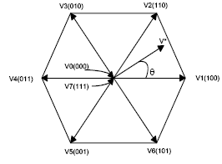
Fig 2.5: Inverter output voltage space vector
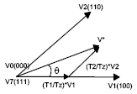
Fig 2.6: Determination of Switching times
The reference space vector V* is given by Equation (1), where T1, T2 are the intervals of application of vector V1 and V2 respectively, and zero vectors V0 and V7 are selected for T0.
V* Tz = V1 *T1 + V2 *T2 + V0 *(T0/2) + V7 *(T0/2)……….(4)
Space Vector Pulse Width Modulation (Continued)
Fig. below shows that the inverter switching state for the period T1 for vector V1 and for vector V2, resulting switching patterns of each phase of inverter are shown in Fig. pulse pattern of space vector PWM.
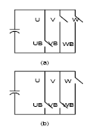
Inverter switching state for (a) V1, (b) V2
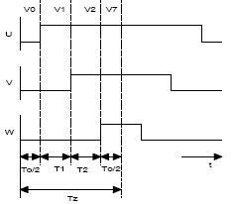
Fig 2.7: Pulse pattern of Space vector PWM
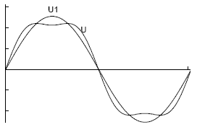
Comparison
In Fig:- comparison, U is the phase to- center voltage containing the triple order harmonics that are generated by space vector PWM, and U1 is the sinusoidal reference voltage. But the triple order harmonics are not appeared in the phase-to-phase voltage as well. This leads to the higher modulation index compared to the SPWM.
Comparison Of SPWM And Space Vector PWM
As mentioned above, SPWM only reaches to 78 percent of square wave operation, but the amplitude of maximum possible voltage is 90 percent of square-wave in the case of space vector PWM. The maximum phase-to-center voltage by sinusoidal and space vector
PWM are respectively
Vmax = Vdc/2 : Sinusoidal PWM
Vmax = Vdc/√3 : Space Vector PWM
Where, Vdc is DC-Link voltage.
This means that Space Vector PWM can produce about 15 percent higher than Sinusoidal PWM in output voltage.
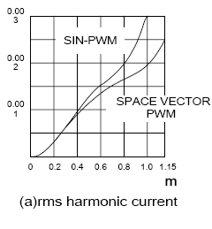
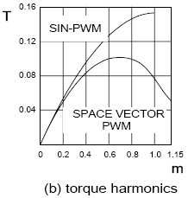
2.6.3: SVM PWM Technique
The Pulse Width modulation technique permits to obtain three phase system voltages, which can be applied to the controlled output. Space Vector Modulation (SVM) principle differs from other PWM processes in the fact that all three drive signals for the inverter will be created simultaneously. The implementation of SVM process in digital systems necessitates less operation time and also less program memory.
The SVM algorithm is based on the principle of the space vector u*, which describes all three output voltages ua, ub and uc :
u* = 2/3 . ( ua + a . ub + a2 . uc ) ………(5)
Where a = -1/2 + j .v3/2 We can distinguish six sectors limited by eight discrete vectors u0…u7 (fig:- inverter output voltage space vector), which correspond to the 23 = 8 possible switching states of the power switches of the inverter.
Fig 2.8: Space vector Modulation
The amplitude of u0 and u7 equals 0. The other vectors u1…u6 have the same amplitude and are 60 degrees shifted.
By varying the relative on-switching time Tc of the different vectors, the space vector u* and also the output voltages ua, ub and uc can be varied and is defined as: ua = Re ( u* )
ub = Re ( u* . a-1)
uc = Re ( u* . a-2) …………(6)
During a switching period Tc and considering for example the first sector, the vectors u0, u1 and u2 will be switched on alternatively.
Definition of the Space vector
Depending on the switching times t0, t1 and t2 the space vector u* is defined as:
u* = 1/Tc . ( t0 . u0 + t1 . u1 + t2 . u2 )
u* = t0 . u0 + t1 . u1 + t2 . u2
u* = t1 . u1 + t2 . u2 ………….. (7)
Where, t0 + t1 + t2 = Tc and
t0 + t1 + t2 = 1
t0, t1 and t2 are the relative values of the on switching times.
They are defined as: t1 = m. cos (a + p/6)
t2 = m. sin a
t0 = 1 - t1 - t2
Their values are implemented in a table for a modulation factor m = 1. Then it will be easy to calculate the space vector u* and the output voltages ua, ub and uc. The voltage vector u* can be provided directly by the optimal vector control laws w1, v_{sa} and v_{sb}. In order to generate the phase voltages ua, ub and uc corresponding to the desired voltage vector u* the following SVM strategy is proposed.

2.7: Three-Level Inverter Analysis
A three-level inverter to ascertain the differences between it and a conventional two-level inverter For a three-phase three-level inverter, a structure similar to that used with 12 electronic devices (IGBT) is needed (Fig. 1). Each phase will switch across three voltage levels (+V _{dc}/2, 0, and -V_{dc}/2). In a structure such as this the maximum voltage across the IGBT is limited to half the maximum dc link voltage (V_{dc}/2). This occurs because the IGBTs are connected to the neutral point (MP) by two fast diodes called neutral clamp diodes.
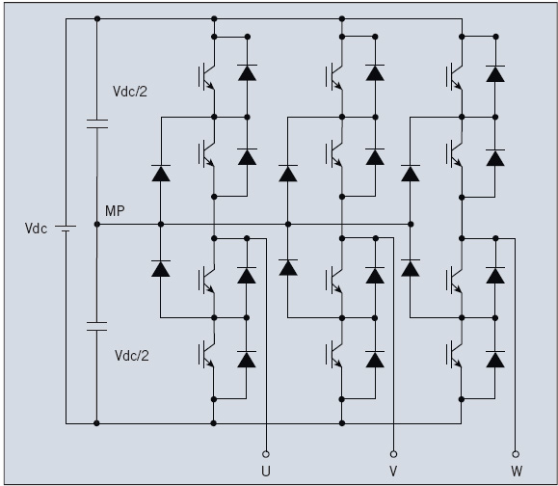

Fig 2.9.Three-phase three-level inverter topology, in which each phase switches across three voltage levels.

Three-phase two-level-inverter (PWM)-generation algorithms can also be applied to multilevel inverters. The algorithms with a triangular carrier waveform produce the best benefits in terms of harmonic distortion reduction, i.e. a three-level inverter needs both a carrier and a reference. In this case the number of triangular carriers is equal to L-1, where L is the number of voltage levels. For a three-phase three-level inverter this means that two triangular carriers and one sinusoidal reference are needed.
Three alternative PWM strategies with differing phase relationships can be used for a three-level inverter:
Alternative phase-opposition disposition (APOD), where carriers in adjacent bands are phase-shifted by 180°.

2.7.1: Three-Level Inverter Benefits
Phase-opposition dispositions (POD), where the carriers above the reference zero point are 180° out of phase with those below zero.
Phase disposition (PD), where all carriers are in phase across all bands.
PD strategy is used most frequently because it produces minimum harmonic distortion for the line-to-line output voltage. Triangular carriers and sinusoidal reference profiles, as well as IGBT and NCD current profiles, are shown in Fig.2
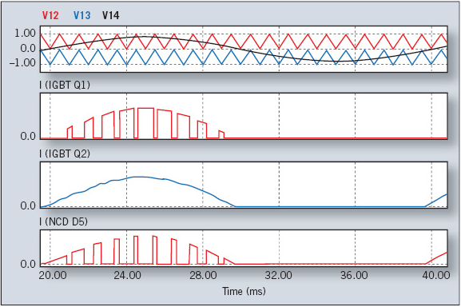
Fig 2.10. Phase disposition (PD) three-level inverter, where all carriers are in phase across all bands and currents profiles.

A three-level inverter appears to comprise highly complex circuitry compared with a two-level inverter. The resulting technical and economic advantages, however, are the reasons why the use of three-level inverters is strongly recommended.
A three-level inverter features an IGBT with a lower reverse-blocking voltage: 600 V instead of 1,200 V. The 600-V chips are normally faster and thinner than 1,200-V chips. The silicon in a three-level inverter therefore has lower switching losses and a lower forward-voltage drop, the total losses per single arm of the three-level inverter are 60% lower than those of the two-level inverter. Q2 and Q3 switching losses are negligible. D1 and D4 diodes carry a very low current value since the current of Q1 commutes to D5; the current of Q4 commutes to D6, and the current of Q2 commutes to Q3. Clamp diodes carry the full load current.

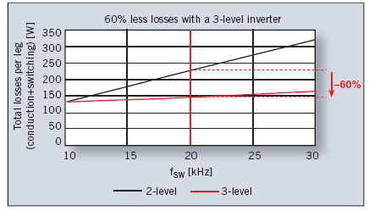
Fig.2.11. overall losses as a function of the switching frequency for a single inverter leg (3L vs.2L )
Source of the charge carriers (electrons for n-channel, holes for p-channel) that flow through the channel; similarly, the drain is where the charge carriers leave the channel.
The device may comprise a Silicon On Insulator (SOI) device in which a Buried OXide (BOX) is formed below a thin semiconductor

3. LITERATURE SURVEY
3.1 Introduction
Recent advances in the power-handling capabilities of static switch devices such as IGBTs with voltage rating up to 4.5 kV commercially available, has made the use of the voltage source inverters (VSI) feasible for high-power applications. High power and high-voltage conversion systems have become very important issues for the power electronic industry handling the large ac drive and electrical power applications at both the transmission and distribution levels. For these reasons, a new family of multilevel inverters has emerged as the solution for working with higher voltage levels. Multilevel inverters include an array of power semiconductors and capacitor voltage sources, the output of which generate voltages with stepped waveforms. Capacitors, batteries, and renewable energy voltage sources can be used as the multiple dc voltage sources. The commutation of the power switches aggregate these multiple dc sources in order to achieve high voltage at the output; however, the rated voltage of the power semiconductor switches depends only upon the rating of the dc voltage sources to which they are connected.

Switch-mode dc-to-ac inverters used in ac power supplies and ac motor drives where the objective is to produce a sinusoidal ac output whose magnitude and frequency can both be controlled. Practically, we use an inverter in both single-phase and three phase ac systems. A half-bridge is the simplest topology, which is used to produce a two level square-wave output waveform. A center-tapped voltage source supply is needed in such a topology. It may be possible to use a simple supply with two well-matched capacitors in series to provide the center tap. Today, multilevel inverters are extensively used in high-power applications with medium voltage levels. The field applications include use in laminators, mills, conveyors, pumps, fans, blowers, compressors, and so on.

3.2 H – Bridge Inverter
“H” topology has many redundant combinations of switches’ positions to produce the same voltage levels. As an example, the level “zero” can be generated with switches in position S(1) and S(2), or S(3) and S(4), or S(5) and S(6), and so on.
Another characteristic of “H” converters is that they only produce an odd number of levels, which ensures the existence of the “0V” level at the load .For example, a 51-level inverter using an “H” configuration with transistor-clamped topology requires 52 transistors, but only 25 power supplies instead of the 50 required when using a single leg. Therefore, the problem related to increasing the number of levels and reducing the size and complexity has been partially solved, since power supplies have been reduced to 50%.
The single-phase H – Bridge of cascaded inverter. The ac terminal voltages of each bridge are connected in series. Unlike the diode clamp or flying capacitors inverter, the cascaded inverter does not require any voltage-clamping diodes or voltage balancing capacitors.
This configuration is useful for constant frequency applications such as active front-end rectifiers, active power filters, and reactive power compensation.
In this case, the power supply could also be voltage regulated dc capacitor. The circuit diagram consists of two cascade bridges. The load is connected in such a way that the sum of output of these bridges will appear across it. The ratio of the power supplies between the auxiliary bridge and the main bridge is 1:3. One important characteristic of multilevel converters using voltage escalation is that electric power distribution and switching frequency present advantages for the implementation of these topologies.
The full-bridge topology is used to synthesize a three-level square-wave output waveform. The half-bridge and full-bridge configurations of the single-phase voltage source inverter are shown in Fig. 3.1and 3.2, respectively. In a single-phase half-bridge inverter, only two switches are needed. To avoid shoot-through fault, both switches are never turned on at the same time. S1 is turned on and S2 is turned off to give a load voltage, V_{AO} in Fig. 3.1, of +V s/2 . To complete one cycle, S1 is turned off and S2 is turned on to give a load voltage, V_{AO} , of -V s/2. In full bridge configuration, turning on S1 and S4 and turning off S2 and S3 give a voltage of V_{S} between point A and B (V_{AB} ) in Fig. 3.5, while turning off S1 and S4 and turning on S2 and S3 give a voltage of -Vs .
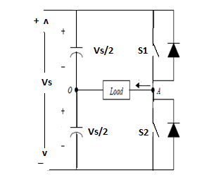
Figure 3.1: Half Bridge Inverter
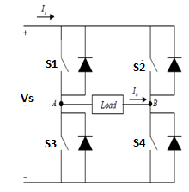
Figure 3.2: Full Bridge Inverter
To generate zero level in a full-bridge inverter, the combination can be S1 and S2 on while S3 and S4 off or vice versa. The three possible levels referring to above discussion are shown in Table 3.1.
Table 3.1: Switching Pattern Of 3 Level Full Bridge Inverter
Conducing Switches | Load Voltage V_{AB}
S₁,S₄ | +Vs
S₁,S₄ | -Vs
S₁,S₄ or S₁,S₄ | 0

Note that S1 and S3 should not be closed at the same time, nor should S2 and S4. Otherwise, a short circuit would exist across the dc source. The output waveform of half bridge and full-bridge of single-phase voltage source inverter are shown in Fig. 3.3 and 3.4 respectively.
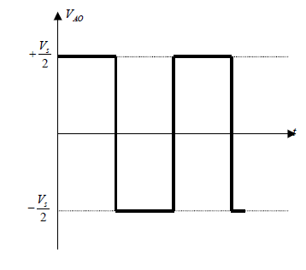
Figure 3.3: Output waveform of Half Bridge Inverter

Figure 3.4: Output waveform of Full Bridge Inverter
3.3 Multilevel Inverters
The term multilevel starts with the three-level inverter introduced by Nabae. By increasing the number of levels in the inverter, the output voltages have more steps generating a staircase waveform, which has a reduced harmonic distortion. However, a high number of levels increases the control complexity and introduces voltage imbalance problems.
An inverter is a device that converts dc input power to ac output power at desired output of voltage and frequency.A multilevel converter has several advantages over a conventional two-level converter that uses high switching frequency pulse width modulation (PWM). The attractive features of a multilevel converter can be briefly summarized as follows.
● Staircase waveform quality: Multilevel converters not only can generate the output voltages with very low distortion, but also can reduce the dv/dt stresses; therefore electromagnetic compatibility (EMC) problems can be reduced.
● Common-mode (CM) voltage: Multilevel converters produce smaller CM voltage; therefore, the stress in the bearings of a motor connected to a multilevel motor drive can be reduced. Furthermore, CM voltage can be eliminated by using advanced modulation strategies such as that proposed in.
● Input current: Multilevel converters can draw input current with low distortion.
● Switching frequency: Multilevel converters can operate at both fundamental switching frequency and high switching frequency PWM. It should be noted that lower switching frequency usually means lower switching loss and higher efficiency.
Unfortunately, multilevel converters do have some disadvantages. One particular disadvantage is the greater number of power semiconductor switches needed. Although lower voltage rated switches can be utilized in a multilevel converter, each switch requires a related gate drive circuit. This may cause the overall system to be more expensive and complex. Plentiful multilevel converter topologies have been proposed during the last two decades. Contemporary research has engaged novel converter topologies and unique modulation schemes. Moreover, three different major multilevel converter structures have been reported in the literature: cascaded H-bridges converter with separate dc sources, diode clamped (neutral-clamped), and flying capacitors (capacitor clamped). Moreover, abundant modulation techniques and control paradigms have been developed for multilevel converters such as sinusoidal pulse width modulation (SPWM), selective harmonic elimination (SHE-PWM), space vector modulation (SVM), and others. In addition, many multilevel converter applications focus on industrial medium-voltage motor drives, utility interface for renewable energy systems, flexible AC transmission system (FACTS) , and traction drive systems.
3.4 Multilevel Power Converter Structures
As previously mentioned, three different major multilevel converter structures have been applied in industrial applications: cascaded H-bridges converter with separate dc sources, diode clamped, and flying capacitors. Before continuing discussion in this topic, it should be noted that the term multilevel converter is utilized to refer to a power electronic circuit that could operate in an inverter or rectifier mode.
Why Use Multilevel Inverters
- In High power circuits if you switch at high frequency switching losses are high.
- Particularly in Low power & low voltage circuits Mosfets are used.
- In Mosfets the conductions losses 70% of total losses and switching losses are 30 % of total losses.
- So switching the Mosfets at high switching frequency not effects the total losses much.
- In case of High power high voltage circuits IGBT’s are used.
- In IGBT’s the conduction losses 50 % of total loss and switching losses are 50 % of total loss. So if you switch at high frequency the efficiency of the system reduces.
- SO in High power High frequency PWM is not suitable, so we need to use multilevel inverter for high power application
The most attractive features of multilevel inverters are as follows.
1) They can generate output voltages with extremely low distortion and lower dv/dt.
2) They draw input current with very low distortion.
3) They generate smaller common-mode (CM) voltage, thus reducing the stress in the motor bearings. In addition, using sophisticated modulation methods, CM voltages can be eliminated.
4) They can operate with a lower switching frequency.
3.5 Classification Of Multilevel Inverters

Figure 3.5: Classification of multilevel Inverters

In General, the multilevel inverters are classified as Single DC source and Multiple DC sources or Several Separate DC Sources (SDCS).Both the Dode Clamped Multilevel Inverter and the Flying Capacitor inverter comes under the category of Single DC source where the input supply is taken from a single DC source.

3.5.1 Diode-Clamped Multilevel Inverter (DCMI)
The diode-clamped inverter was also called the neutral-point clamped (NPC) inverter when it was first used in a three-level inverter in which the mid-voltage level was defined as the neutral point. The diode-clamped multilevel inverter uses capacitors in series to divide up the dc bus voltage into a set of voltage levels. To produce m levels of the phase voltage, an m level diode-clamp inverter needs m-1 capacitors on the dc bus. A single-phase five-level diode-clamped inverter is shown in Fig. 1.9. The dc bus consists of four capacitors, i.e., C1, C2, C3, and C4. For a dc bus voltage Vdc, the voltage across each capacitor is Vdc/4, and each device voltage stress will be limited to one capacitor voltage level, Vdc/4, through clamping diodes. DCMI output voltage synthesis is relatively straightforward.
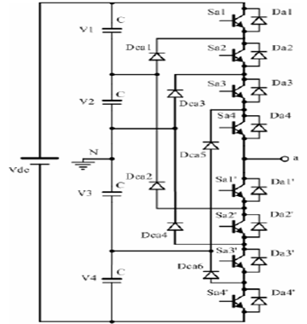
Figure 3.6: Five level diode clamped MLI
To explain how the staircase voltage is synthesized, point O is considered as the output phase voltage reference point. Using the five-level inverter shown in Fig. 1.10, there are five switch combinations to generate five level voltages across A and O. Table 3.2 shows the phase voltage level and their corresponding switch states. From Table 3.2, state 1 represents that the switch is on, and state 0 represents the switch is off. In each phase leg, a set of four adjacent switches is on at any given time. There exist four complimentary switch pairs in each phase, i.e., Sa1-Sa1’, Sa2-Sa2’, and Sa4-Sa4’.

Table 3.2 Diode-Clamped Five-Level Inverter Voltage Levels And Their Switch States
Output V_{AO} | Switch state
Output V_{AO} | S_{a1} | S_{a2} | S_{a3} | S_{a4} | S_{a1’} | S_{a2’} | S_{a3’} | S_{a4’}
V₅=V_{dc} | 1 | 1 | 1 | 1 | 0 | 0 | 0 | 0
V₄=3V_{dc /4} | 0 | 1 | 1 | 1 | 1 | 0 | 0 | 0
V₃=V_{dc}/2 | 0 | 0 | 1 | 1 | 1 | 1 | 0 | 0
V₂=V_{dc}/4 | 0 | 0 | 0 | 1 | 1 | 1 | 1 |  | 0
V₁=0. | 0 | 0 | 0 | 0 | 1 | 1 | 1 |  | 1

Features

- High-Voltage Rating Required for Blocking Diodes. Although each active switching device is only required to block a voltage level of Vdc/(m - l), the clamping diodes
Advantages
- All of the phases share a common dc bus, which minimizes the capacitance requirements of the converter. For this reason, a back-to-back topology is not only possible but also practical for uses such as a high-voltage back-to-back inter-connection or an adjustable speed drive.
- The capacitors can be pre-charged as a group.
- Efficiency is high for fundamental frequency switching.

Disadvantages
- Real power flow is difficult for a single inverter because the intermediate dc levels will tend to overcharge or discharge without precise monitoring and control.
- The number of clamping diodes required is quadratically related to the number of levels, which can be cumbersome for units with a high number of levels.
3.5.2 Flying-capacitor Multilevel Inverter (FCMI)
A FCMI shown in Fig. 1.10 uses a ladder structure of dc side capacitors where the voltage on each capacitor differs from that of the next capacitor. To generate m-level staircase output voltage, m-1 capacitors in the dc bus are needed. Each phase-leg has an identical structure. The size of the voltage increment between two capacitors determines the size of the voltage levels in the output waveform.
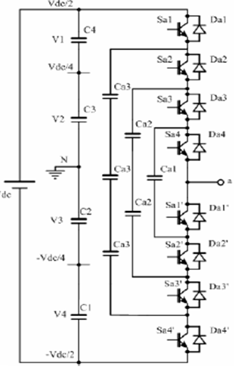
Figure 3.7 :Five Level Flying Capacitor MLI

In fact, there is more than one combination to produce output voltages V2, V3, and V4. That makes the FCMI more flexibility than DCMI. Table 3.3, however, shows only one possible combination.
Table 3.3 Switching States Of Five Level Capacitor MLI
Output V_{AO} | Switch state
Output V_{AO} | S_{a1} | S_{a2} | S_{a3} | S_{a4} | S_{a1’} | S_{a2’} | S_{a3’} | S_{a4’}
V₅=V_{dc} | 1 | 1 | 1 | 1 | 0 | 0 | 0 | 0
V₄=3V_{dc /4} | 1 | 1 | 1 | 0 | 1 | 0 | 0 | 0
V₃=V_{dc}/2 | 1 | 1 | 0 | 0 | 1 | 1 | 0 | 0
V₂=V_{dc}/4 | 1 | 0 | 0 | 0 | 1 | 1 | 1 |  | 0
V₁=0. | 0 | 0 | 0 | 0 | 1 | 1 | 1 |  | 1

Advantages
- Phase redundancies are available for balancing the voltage levels of the capacitors.
- Real and reactive power flow can be controlled.
- The large number of capacitors enables the inverter to ride through short duration outages and deep voltage sags.
Disadvantages
- Control is complicated to track the voltage levels for all of the capacitors. Also, precharging all of the capacitors to the same voltage level and startup are complex.
- Switching utilization and efficiency are poor for real power transmission.
- The large numbers of capacitors are both more expensive and bulky than clamping diodes in multilevel diode-clamped converters. Packaging is also more difficult in inverters with a high number of levels.

3.5.3 Cascaded H-Bridge Multilevel Inverter
The cascaded H-bridge multilevel Inverter uses separate dc sources (SDCSs). The multilevel inverter using cascaded-inverter with SDCSs synthesizes a desired voltage from several independent sources of dc voltages, which may be obtained from either batteries, fuel cells, or solar cells. This configuration recently becomes very popular in ac power supply and adjustable speed drive applications. This new inverter can avoid extra clamping diodes or voltage balancing capacitors. Again, the cascaded multilevel inverters are classified depending the type of DC sources used throughout the input.

A single-phase structure of an m-level cascaded inverter is illustrated in Figure 3.8 Each separate dc source (SDCS) is connected to a single-phase full-bridge, or H-bridge, inverter. Each inverter level can generate three different voltage outputs, +V_{dc}, 0, and –V_{dc} by connecting the dc source to the ac output by different combinations of the four switches, S₁, S₂, S₃, and S₄. To obtain +V_{dc}, switches S₁ and S₄ are turned on, whereas –V_{dc} can be obtained by turning on switches S₂ and S₃. By turning on S₁ and S₂ or S₃ and S₄, the output voltage is 0. The ac outputs of each of the different full-bridge inverter levels are connected in series such that the synthesized voltage waveform is the sum of the inverter outputs. The number of output phase voltage levels m in a cascade inverter is defined by m = 2s+1, where s is the number of separate dc sources. An example phase voltage waveform for an 11-level cascaded H-bridge inverter with 5 SDCSs and 5 full bridges is shown in Figure 3.7. The phase voltage v_{an} = v_{a1} + v_{a2} + v_{a3} + v_{a4} + v_{a5}.

For a stepped waveform such as the one depicted in Figure 3.7 with s steps, the Fourier Transform for this waveform follows

Figure 3.8 Single-Phase Structure Of A Multilevel Cascaded H-Bridge Inverter.
Figure 3.9.Output Phase Voltage Waveform Of An 11-Level Cascade Inverter
With 5 Separate Dc Sources.

From below eq’n the magnitudes of the Fourier coefficients when normalized with respect to V_{dc} Are as follows

The conducting angles, θ₁, θ₂, ..., θ_{s}, can be chosen such that the voltage total harmonic distortion is a minimum. Generally, these angles are chosen so that predominant lower frequency harmonics, 5th, 7th, 11th, and 13th, harmonics are eliminated. More detail on

3.5.4 Symmetrical Cascaded H-Bridge Multilevel Inverter
If all the input sources are of equal magnitude, it is known as Symmetrical H-Bridge inverter as shown in fig 3.9 and the switching sequence is given in table 2.3 .Here both the full bridge inverters are fed with different sources of equal magnitude.
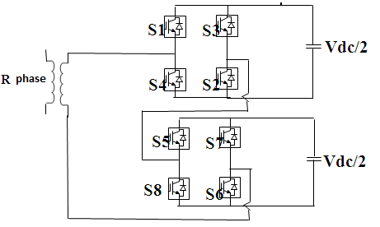
Fig 3.10: Symmetrical Five Level Cascaded H-Birdge Inverter

In the above fig, each SDCS of equal magnitude is associated with a single-phase full-bridge inverter. The ac terminal voltages of different level inverters are connected in series. By different combinations of the four switches, S1-S4, each inverter level can generate three different voltage outputs, +Vdc, -Vdc, and zero. The ac output of each of the different level of full-bridge inverters are connected in series such that the synthesized voltage waveform is the sum of the inverter outputs. In this topology, the number of output phase voltage levels is defined by m = 2s+1, where s is the number of dc sources.
A 5-level cascaded-inverters will have two SDCSs and two full-bridge cells. The switching table for the five level cascaded inverter is shown below. Here, 2 Full Bridges are used and are cascaded to each other. The Switches S1, S2, S3,and S4 are from upper H-Bridge and Switches S5 S6 S7 and S8 are from lower H-Bridge .By giving correct switching patter n ,we get 5 voltage levels i.e 2Vdc,Vdc,0,-2Vdc,- Vdc, S1,S2,S5,D7 are on .To get 2Vdc, S1,S2,S6,S5 are kept on .The switching table is shown below to get 5 levels with a Symmetrical DC source.
Table 3.4: Switching States Of Symmetrical Five Level Cascaded H-Bridge Inverter

Switches ON | Voltage level
S1, S2, S5 and D7 | Vdc/2
S1, S2, S6and S5 | Vdc
S1, S2, S6 and D8 | Vdc/2
S1, D3, S6 and D8 | 0
S3, S4, S6 and D8 | -Vdc/2
S3, S4, S7 and S8 | -Vdc
S3, S4, D6 and S8 | -Vdc/2
S1, S3, D6 and S8 | 0

Fig.3.11 Output Waveform Of Symmetrical Cascaded H-Bridge Multilevel Inverter
3.5.5 Asymmetrical Cascaded H-Bridge Multilevel Inverter
The cascaded H-Bridge multilevel inverter with two SDCS with unequal magnitude is known as Asymmetrical Cascaded H-Bridge multilevel Inverter. The following is figure 3.15 of Asymmetrical Cascaded H-Bridge multilevel Inverter where it is having 2 unequal DC sources +2Vdc/3 and +Vdc/3.
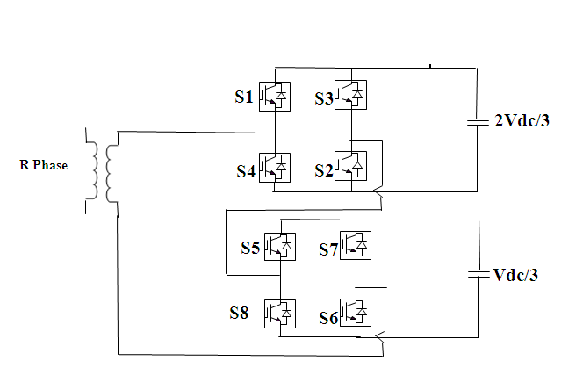
Fig.3.12 Asymmetrical Cascaded H-Bridge Multilevel Inverter
By using this type of Asymmetrical configuration, for a ‘n’ bridge inverter we can get 3n+1 voltage levels and n Capacitors of each rating nVdc/(n+1), Vdc/(n+1) to get Vdc max and 6n switches of each voltage rating is Vdc/(n+1).The following is the switching table of Asymmetrical Cascaded H-Bridge multilevel Inverter.
Table 3.5: Switching States Of Asymmetrical Five Level Cascaded H-Bridge Inverter
Switches ON | Voltage level
S4, S2, S5 and S6 | Vdc/3
S1, S2, S8 and S6 | 2Vdc/3
S1, S2, S5and S6 | Vdc
S4, S2, S7 and S8 | -Vdc/3
S3, S4, S6 and S8 | -2Vdc/3
S3, S4, S7 and S8 | -Vdc
S4, S2, S8 and S6 | 0
A Generalized structure of single-phase Cascaded m-level configuration of H-Bridge inverter is shown in Fig 3.16
Figure 3.13 Single-Phase Structure Of A Multilevel Cascaded Inverter.

Depending on the number of levels, the bridges are cascaded. In this topology, the number of output phase voltage levels is defined by m = 2s+1, where s is the number of dc sources. The following is the generalized structure of Cascaded H-Bridge multilevel inverter.

  - Modulation Topologies For Multilevel Inverters
Almost all power electronic inverters are operated in the “switched mode”. This means the switches within the inverter are always in either one of two states — turned off (so no current flows), or saturated (turned on completely, with only a small voltage drop across the switch). Any operation in the linear region, other than for the unavoidable transition from conducting to non-conducting, incurs an undesirable loss of efficiency and an unbearable rise in switch power dissipation. To control the flow of power in the inverter, the switches alternate between these two states. This happens rapidly enough that the inductors and capacitors at the input and output nodes of the inverter average or filter the switched signal. The switched component is attenuated and the desired DC or low frequency AC component is retained. This process is called Pulse Width Modulation (PWM), since the desired average value is controlled by modulating the width of the pulses.
To achieve the greatest possible attenuation of the switching component, it is generally desirable that the switch frequency f_{c} is high — many times the frequency of the desired fundamental AC component f₁ seen at the input or output terminals. Two requirements which all low pulse number PWM candidates should observe are synchronism with the fundamental frequency and quarter and half wave symmetry.
Synchronism with the fundamental frequency means ensuring the switching frequency f_{c} is an integer multiple of the synthesized fundamental frequency f₁. That is, the pulse number N=f_{c}/f₁ must be an exact integer. The frequency spectrum of the PWM waveform will then consist of discrete frequencies at multiples of the fundamental frequency nf₁, where n is an integer. Quarter and half wave symmetry ensures that no even harmonics will exist in the output spectrum [8]. This can be achieved by choosing N odd. An important even harmonic which is eliminated is the DC component.
No frequency components below the fundamental frequency (commonly referred to as sub-harmonics) will exist. This is important since an undesired harmonic component near zero frequency, even if small in amplitude, can cause large currents to flow in inductive loads. Beyond these basic requirements, there are many different ways of generating PWM switching edges. Any technique can probably be placed into one of the following three categories:
- Off-line or pre-calculated PWM technique
- Hysteresis control PWM
- Carrier based PWM.
3.6.1 Off-line or Pre-Calculated PWM Technique
Selective Harmonic Elimination (SHE) and Selective Harmonic Minimization (SHM) are two off-line (pre-calculated) non carrier based PWM techniques. SHE was proposed in a early paper by Patel and Hoft . Accepting first the conditions of quarter and half wave symmetry to cancel all even harmonics, the angles of the switching edges in the first quarter cycle can be considered variables for optimization. Each angle is one degree of freedom. For each degree of freedom, one harmonic may be set to zero or any other reasonable desired value. Using Fourier transforms, simultaneous equations in these angles are solved given desired values for the fundamental and the lowest significant harmonics. These calculations are slow and are done off-line. A look up table of edge angles is created which the on-line controller uses to set the edge times. A summary of Harmonic elimination PWM techniques is presented by Enjeti et al.
Optimal PWM or selected harmonic elimination PWM (SHE-PWM) seems attractive, but cannot react to transients quickly. This is because pulses do not occur at fixed intervals, that is, the switch period is not constant. Moving one edge may completely upset the optimized spectrum. Closed loop control using
SHE/SHM is generally limited to cycle by cycle control of the fundamental frequency and modulation depth. Some works have been done on closing feedback loops around optimized PWM modulators to remove errors when they occur. These techniques cannot compensate for distortions due to DC bus ripple, or switching imperfections.
3.6.2 Hysteresis Control PWM
A hysteresis band modulator calculates the error between the desired output and the measured output. The state of the switches is changed when this error exceeds a certain bound (leaves the hysteresis band) so as to drive the error back within that bound. This method requires that the controlled output quantity of the inverter is integrated either by the load, or as part of the controller. For example, in a voltage source hysteretic inverter, the output current (the measured and subsequently controlled quantity) will be integrated by an inductive load.
This technique has the advantage of bounded, predictable error and fast transient response to changes at either the input or the output. It is closed loop by nature and demonstrates low distortion. It is simple to implement in its simplest form. It has however a number of disadvantages, which limit its usefulness to low power, high switching frequency applications.
One disadvantage is the variable nature of the switch period. Because of this, the output spectrum is continuous and spread to an extent, rather than discrete and grouped as with carrier based techniques. Further, the switching instants are not necessarily synchronous or cyclic and so sub-harmonics may be present. For these reasons, hysteresis control is not applied for low switching frequencies.
One method of eliminating sub-harmonics is to force quarter wave symmetry by resetting the error at each zero crossing and forcing a switching, and hence a reflection of the pattern, at 90 degrees. This gives discrete spectra without sub-harmonics. Another technique which limits the variations in switching frequency is to modulate the width of the hysteresis band. This places upper and lower limits on the switching frequency, but does not address the problem of sub-harmonics.
3.6.3 Carrier Based PWM Techniques
There are many variations of carrier based PWM.
- analog vs. digital
- sine-triangle vs. space vector (in reality very similar)
- triangular vs. saw tooth carrier
- symmetric vs. asymmetric (sampled once/twice per triangle)
- uniform sampling vs. natural sampling
- Periodic vs. aperiodic carrier.
For the purposes of defining this broad category, carrier based PWM methods are those where the switching decisions of the inverter are made for each switching cycle either at the beginning or during that switch cycle. That is, the PWM waveform is calculated on a cycle by cycle basis, either pulse by pulse, or edge by edge. This distinguishes it from SHE and SHM PWM, where multiple switching edges are mapped out for the entire fundamental period or some fraction therein; and hysteresis PWM, where neither edges nor switch period are defined, calculated or even known in advance. A comparison of waveforms and frequency spectra of three different PWM strategies are shown in Fig. 1.17 below.
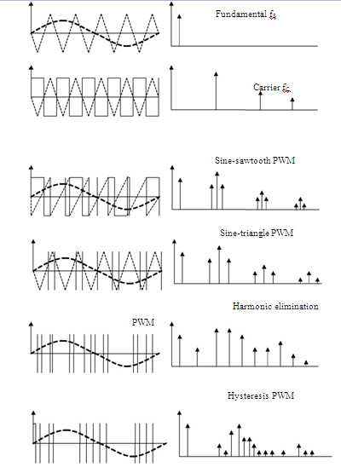

Figure 3.14 From The Top, Wave Forms And Frequency Spectra Of The Original Sinusoidal Modulating Waveform, The Unmodulated PWM Square Wave, Sine-Saw Tooth (Single Edge Carrier) PWM, Sine-Triangle (Double Edge Carrier) PWM, Selective Harmonic Elimination (SHE) PWM And Hysteresis PWM.
The two basic approaches used to generate the PWM signals for multilevel inverters are:
- Sub harmonic or Sub-Oscillation carrier based PWM-modulating waveform comparison with offset triangular carriers.
- Space Vector PWM-space vector modulation based on a rotating vector in multilevel space.
These are the extensions of traditional two level control strategies to several levels.The two main advantages of PWM inverters in comparison to square-wave inverters are
(i) control over output voltage magnitude
(ii) Reduction in magnitudes of unwanted harmonic voltages.
Good quality output voltage in SPWM requires the modulation index (m) to be less than or equal to 1.0. For m>1 (over-modulation), the fundamental voltage magnitude increases but at the cost of decreased quality of output waveform. The maximum fundamental voltage that the SPWM inverter can output (without resorting to over-modulation) is only 78.5% of the fundamental voltage output by square-wave inverter.
The merits and demerits of these two PWM techniques are compared under comparable circuit conditions on the basis of factors like (i) quality of output voltage (ii) obtainable magnitude of output voltage (iii) ease of control etc. The peak obtainable output voltage from the given input dc voltage is one important figure of merit for the inverter.
Carrere considered different methods of disposing the many carrier bands required in multilevel PWM.
Four alternative carrier PWM strategies with differing phase relationships for a multilevel inverter are as follows:
1) In-phase disposition (IPD), where all the carriers are in phase- Technique A1
2) Phase opposition disposition (POD), where the carriers above the zero reference are in phase, but shifted by 1800 from those carriers below the zero reference- Technique A2
3) Alternative phase opposition disposition (APOD), where each carrier band is shifted by 1800 from the adjacent bands- Technique A3; 4) Phase Disposition (PD), all the carriers are phase shifted by 2N/(N-1) radians- Technique B.PD strategy is used most frequently because it produces minimum harmonic distortion for the line–to–line output voltage.
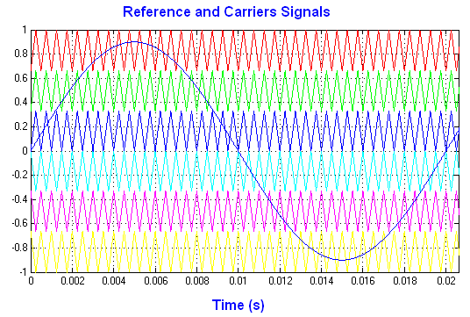
Fig. 3.15 Reference And Carriers Signals For SHPWM Technique.
Fig. 3.15 shows generation of reference and carriers signal for SHPWM technique, which is used to control the switches of TBMCSL H- bridges inverter
3.7 Pulse Modulation Schemes

3.7.1 Pulse Amplitude Modulation

Pulse Amplitude Modulation refers to a method of carrying information on a train of pulses, the information being encoded in the amplitude of pulses. In other words the pulse amplitude is modulated according to the varying amplitude of analog signal.

3.7.2 Pulse Width Modulation

Pulse Width Modulation refers to a method of carrying information on a train of pulses, the information being encoded in the width of the pulses. The pulses have constant amplitude but their duration varies in direct proportion to the amplitude of analog signal.
3.7.3 Pulse Position Modulation

The amplitude and width of the pulse is kept constant in the system. The position of each pulse, in relation to the position of a recurrent reference pulse, is varied by each instantaneous sampled value of the modulating wave. PPM has the advantage of requiring constant transmitter power since the pulses are of constant amplitude and duration.

3.8 Advantages Of PWM
- The output voltage control is easier with PWM than other schemes and can be achieved without any additional components.
- The lower order harmonics are either minimized or eliminated altogether.
- The filtering requirements are minimized as lower order harmonics are eliminated and higher order harmonics are filtered easily.
- It has very low power consumption.
- The entire control circuit can be digitized which reduces the susceptibility of the circuit to interference.

3.9 Single Phase PWM Inverters
In many industrial applications, to control the output voltage of the inverters is necessary for the following reasons
- To adjust with variations of dc input voltage
- To regulate voltage of inverters
- To satisfy the contain volts and frequency control requirement
There are various techniques to vary the inverter gain. The most efficient method of Controlling the gain (and output voltage) is to incorporate pulse width modulation (PWM) Control within the inverters. The commonly used techniques are
a) Single Pulse width Modulation
b) Multiple Pulse width Modulation
c) Sinusoidal Pulse width Modulation
d) Modified sinusoidal Pulse width Modulation
e) Phase-displacement control.
The PWM techniques given above vary with respect to the harmonic content in their output voltages.
3.10 Single Pulse Width Modulation

In this control, there’s only one pulse per half cycle and the width of the pulse is varied to control the inverter output. The gating signals are generated by comparing a rectangular reference signal of the amplitude Ar with triangular carrier wave of amplitude Ac, the frequency of the carrier wave determines the fundamental frequency of output voltage. By varying Ar from 0 to Ac ,the pulse width can be varied from 0 to 100 percent. The ratio of Ar to Ac is the control variable and defined as the modulation index.
3.11 Multiple Pulse Width Modulation
The harmonic content can be reduced by using several pulses in each half cycle of output voltage. The generation of gating signals for turning ON and OFF transistors by comparing a reference signal with a triangular carrier wave. The frequency Fc, determines the number of pulses per half cycle. The modulation index controls the output voltage. This type of modulation
is also known as uniform pulse width modulation (UPWM)
3.12 Sinusoidal Pulse Width Modulation

Instead of, maintaining the width of all pulses of same as in case of multiple pulse width Modulation, the width of each pulse is varied in proportion to the amplitude of a sine wave Evaluated at the centre of the same pulse. The distortion factor and lower order harmonics are Reduced significantly. The gating signals are generated by comparing a sinusoidal reference Signal with a triangular carrier wave of frequency Fc. The frequency of reference signal Frequency , determines the inverter output frequency and its peak amplitude Ar, controls the modulation Index M and rms output voltage Vo. The number of pulses per half cycle depends on carrier Frequency.

3.13 PWM For Multilevel Inverter
There are types of PWM techniques for Multilevel Inverter.
- Phase shifted Carrier PWM
- Level Shifted Carrier PWM

3.13.1 Phase Shifted PWM

If the Number of voltages m=5, the number of carriers required are m_{C}-1=4 and the
Phase shift=360⁰ / m_{C} =90⁰
3.13.2 Level Shifted PWM

4. PROPOSED CONCEPT
4.1 Introduction
Inverters are very popular power electronic devices which are widely used in adjustable speed motor drivers, power supplies and photovoltaic cells. These devices are used to create single or poly phase AC voltage from a dc source.The inverter sinusoidal output waveform causes the output harmonics to be optimized. The presented inverters in this paper are:
A) Cascade H-bridge
B) Incremental cascade H-bridge
C) Incremental cascade I–bridge
D) Incremental – reduction cascade H-bridge
E) Combined cell cascade
More details on these multilevel topologies are highlighted later. In this paper, after presenting the 5 multilevel inverters block diagram, their features, and also output waveforms, their MATLAB simulation comparison results are declared. A new structure of multilevel inverter is presented which significantly increases the number of output voltage levels for the same number of stages which is reduced the low order harmonics and also the total harmonic distortion (THD). Elimination of low order harmonics and reduction of THD in the output voltage are generally desired because their filtering is so hard. It's also explained that how using a technique in a topology, helps decreasing of the switches number. As well, it's declared that how the cell with higher DC link voltage has lower switching frequency which causes reduction in switching losses.
4.2 Cascade Structure Multilevel Inverter
The basic features of various cascade multilevel topologies are summarized in this section. The output voltage waveform and the harmonic chart of each topology are also presented.
A. Cascade H-Bridge Multilevel Inverter
Fig. 4.1 shows the block diagram of a single phase leg of the cascade H-bridge multilevel inverter. The output waveform levels consist of S×VDC where S is the number of the separated dc sources or the number of the cells. The number of levels in the output waveform is equal to 2S+1.
Figure 4.1 Cascade H-Bridge Multilevel Inverter
B. Incremental Cascade H-Bridge
This section introduces a topology based on the cascade H-bridge named incremental cascade H-bridge (Fig. 4.2). It increases the number of output waveform levels thereby considerably reduces the low order harmonics and also THD.
One of the advantages of the structure is that the stage with higher DC-link voltage has lower number of commutations which reduces the associated switching losses on one hand and by using special technique reduces the number of the switching devices on the other hand. The number of output levels is 2S+1 where S is the number of the separated dc sources or the number of the cells.

Figure 4.2 Incremental Cascade H-Bridge
C. Incremental Cascade I-Bridge
Fig. 4.3 shows the block diagram of a single phase leg for the incremental cascade I-bridge. In this topology one leg of H-bridge is canceled by using special method.
A switch can be removed from the circuit, without any difference in the situation during a period. In this case we can use usual state instead of switch. We can create the half period (positive or negative) of original output waveform and use H-bridge cell to produce another half period (positive or negative) in different time. So the main cell cycle becomes shorter. Special switching method can be selected to put switches in permanent status which causes some of them be removed. The number of switches in this topology is less than H-bridge topology:
b = (S×4) For H-bridge topology
b = (S×2) +4 For I-bridge topology
Figure 4.3 Incremental Cascade I-Bridge
As it's shown the output waveform has 15 levels :±7VDC , ±6VDC , ±5VDC , ±4VDC , ±3VDC , ±2VDC , ±1VDC and 0. But it only uses 8 switches instead of 12 switches in incremental cascade H-bridge. Note that the original cells have the module properties.

D. Incremental - Reduction Cascade H-Bridge
The block diagram of a single phase leg for the incremental-reduction
cascade H-bridge is shown in Fig. 4.4
Figure 4.4 Incremental-Reduction Cascade H-Bridge.

The inverter consists of H-bridge while the DC-link voltage among the cells is 1V, 3V, 9V,… . In this topology the original output is the summation of all cells output. Each cell can produce positive or negative polarities.

E. Combined Cell Cascade Multilevel Inverter
In this section a different structure of cascade topology is introduced. The structure called combined cascade topology has the highest number of levels due to the number of cells in cascade
In the structure, each cell increases the number of the original output levels. In fact all the cells are finally gathered together like separated multilevel inverter. The block diagram of the combined cascade multilevel inverter is presented in Fig. 4.5 If it uses more capacitors and auxiliary switches, the number of output voltage levels is increased. The number of output voltage levels of each cell isequal to:
M=2C+1
Where, C is the number of capacitors. Output voltage and switching state of the combined cascade multilevel inverter cell is presented in Table I.
Figure 4.5 Combined Cascade Multilevel Inverter Cell With 5 Output Voltage Levels.

TABLE 4.1 Output Voltage And Switching State Of Combined Cascade Multilevel Inverter Cell

4.3 Comparison Results
Table 4.2 includes the comparison results of various multilevel inverters of the presented paper. The number of output voltage levels of the last topology is increased significantly in comparison with the others and has the highest number of levels due to the number of cells . The number of switches, separated dc sources and the amount of THD in each topology, are also shown for S=2 in Table II. Note that several PWM techniques have been proposed for multilevel PWM control. Here, harmonic elimination PWM technique is used to eliminate lower order harmonics and reduce THD.

Table 4.2 Comparison Results For Five Multilevel Inverters

5.SIMULATION RESULTS
MATLAB is a high-performance language for technical computing. It integrates computation, visualization, and programming in an easy-to-use environment where problems and solutions are expressed in familiar mathematical notation. Typical uses include-
- Math and computation
- Algorithm development
- Data acquisition
- Modeling, simulation, and prototyping
- Data analysis, exploration, and visualization
- Scientific and engineering graphics
MATLAB is an interactive system whose basic data element is an array that does not require dimensioning. This allows solving many technical computing problems, especially those with matrix and vector formulations, in a fraction of the time it would take to write a program in a scalar non-interactive language such as C or FORTRAN.
The MATLAB system consists of six main parts:
(a) Development Environment
This is the set of tools and facilities that help to use MATLAB functions and files. Many of these tools are graphical user interfaces. It includes the MATLAB desktop and Command Window, a command history, an editor and debugger, and browsers for viewing help, the workspace, files, and the search path.
(b) The MATLAB Mathematical Function Library
This is a vast collection of computational algorithms ranging from elementary functions, like sum, sine, cosine, and complex arithmetic, to more sophisticated functions like matrix inverse, matrix Eigen values, Bessel functions, and fast Fourier transforms.
(c)The MATLAB Language
This is a high-level matrix/array language with control flow statements, functions, data structures, input/output, and object-oriented programming features. It allows both "programming in the small" to rapidly create quick and dirty throw-away programs, and "programming in the large" to create large and complex application programs.
(d) Graphics
MATLAB has extensive facilities for displaying vectors and matrices as graphs, as well as annotating and printing these graphs. It includes high-level functions for two-dimensional and three-dimensional data visualization, image processing, animation, and presentation graphics. It also includes low-level functions that allow to fully customize the appearance of graphics as well as to build complete graphical user interfaces on MATLAB applications.
(e)The MATLAB Application Program Interface (API)
This is a library that allows writing in C and FORTRAN programs that interact with MATLAB. It includes facilities for calling routines from MATLAB (dynamic linking), calling MATLAB as a computational engine, and for reading and writing MAT-files.
(f) MATLAB Documentation
MATLAB provides extensive documentation, in both printed and online format, to help to learn about and use all of its features. It covers all the primary MATLAB features at a high level, including many examples. The MATLAB online help provides task-oriented and reference information about MATLAB features. MATLAB documentation is also available in printed form and in PDF format.
(g) Mat lab tools
(i) Three Phase Source Block
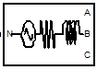
The Three-Phase Source block implements a balanced three-phase voltage source with internal R-L impedance. The three voltage sources are connected in Y with a neutral connection that can be internally ground.
(ii) VI Measurement Block
The Three-Phase V-I Measurement block is used to measure three-phase voltages and currents in a circuit. When connected in series with three-phase elements, it returns the three phase-to-ground or phase-to-phase voltages and the three line currents
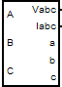
(iii) Scope
Display signals generated during a simulation. The Scope block displays its input with respect to simulation time. The Scope block can have multiple axes (one per port); all axes have a common time range with independent y-axes. The Scope allows you to adjust the amount of time and the range of input values displayed. You can move and resize the Scope window and you can modify the Scope's parameter values during the simulation

(iv) Three-Phase Series RLC Load
The Three-Phase Series RLC Load block implements a three-phase balanced load as a series combination of RLC elements. At the specified frequency, the load exhibits constant impedance. The active and reactive powers absorbed by the load are proportional to the square of the applied voltage.
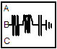
Three-Phase Series RLC Load
(v) Three-Phase Breaker block
The Three-Phase Breaker block implements a three-phase circuit breaker where the opening and closing times can be controlled either from an external Simulink signal or from an internal control signal.

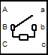
Three-Phase Breaker block
(vi) Gain block
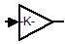
Gain block
The Gain block multiplies the input by a constant value (gain). The input and the gain can each be a scalar, vector, or matrix.

5.1 Simulation Diagrams and Results:
Cascaded H-Bridge Multilevel Inverter
g
m
C
E
s5
g
m
C
E
s4
g
m
C
E
s3
g
m
C
E
s2
g
m
C
E
s1
Continuous
powergui
v
+
-
Voltage Measurement
Scope
Repeating
Sequence4
Repeating
Sequence3
Repeating
Sequence2
Repeating
Sequence1
Repeating
Sequence
R
DC2
DC1
m
a
k
D4
m
a
k
D3
m
a
k
D2
m
a
k
D1
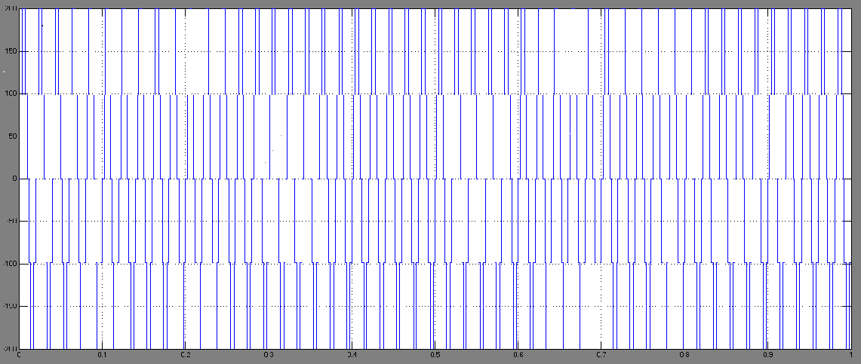
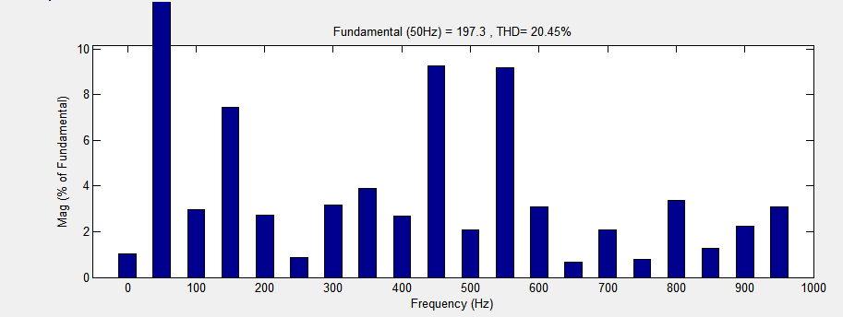
Incremental Cascaded H-Bridge Multilevel Inverter
Discrete,
Ts = 5e-005 s.
powergui
v
+
-
Voltage Measurement
R
Scope
Repeating
Sequence3
Repeating
Sequence2
Repeating
Sequence1
Repeating
Sequence
NOT
Logical
Operator3
NOT
Logical
Operator2
NOT
Logical
Operator1
NOT
Logical
Operator
g
m
C
E
IGBT/Diode7
g
m
C
E
IGBT/Diode6
g
m
C
E
IGBT/Diode5
g
m
C
E
IGBT/Diode4
g
m
C
E
IGBT/Diode3
g
m
C
E
IGBT/Diode2
g
m
C
E
IGBT/Diode1
g
m
C
E
IGBT/Diode
DC Voltage Source1
DC Voltage Source

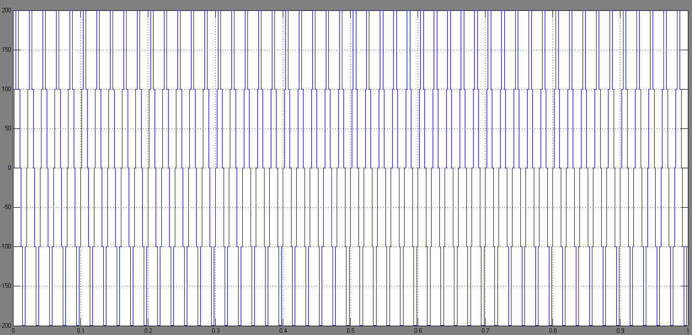
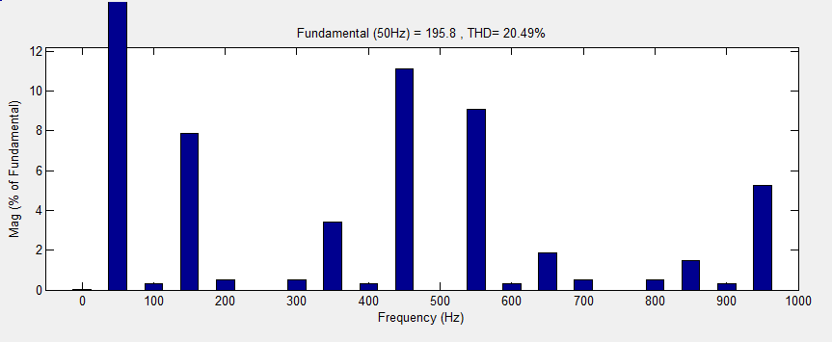
Incremental Cascaded I-Bridge Multilevel Inverter
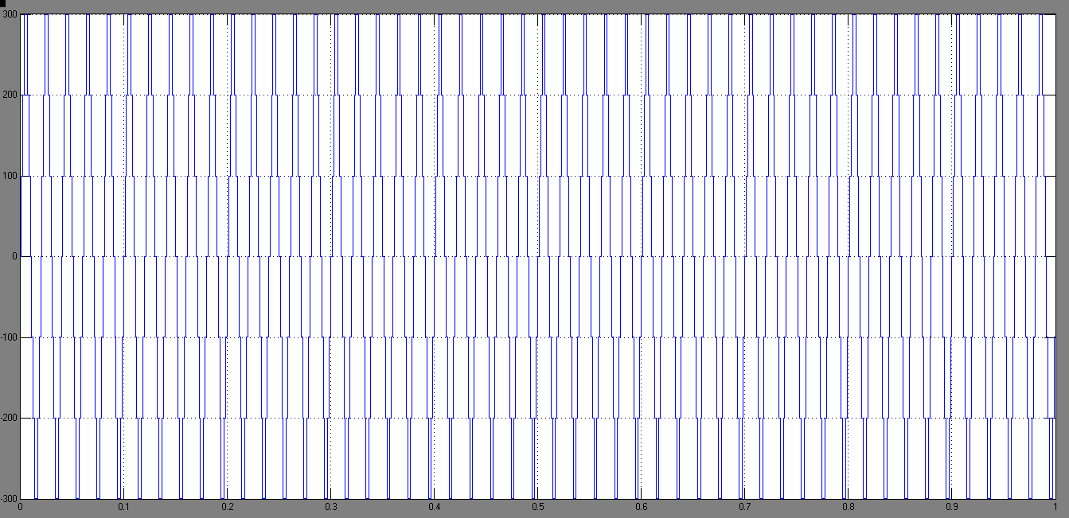
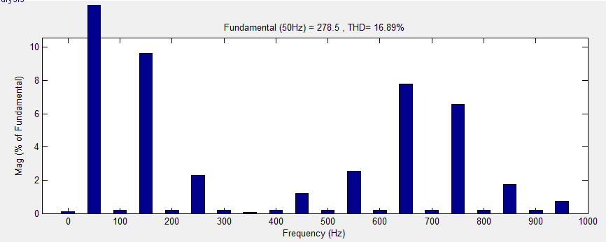
Incremental-Reduction Cascade H-Bridge Multilevel Inverter 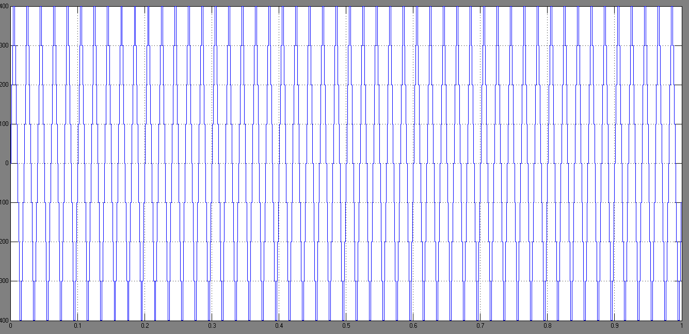
Discrete,
Ts = 5e-005 s.
powergui
v
+
-
Voltage Measurement
R
Scope
Repeating
Sequence3
Repeating
Sequence2
Repeating
Sequence1
Repeating
Sequence
NOT
Logical
Operator3
NOT
Logical
Operator2
NOT
Logical
Operator1
NOT
Logical
Operator
g
m
C
E
IGBT/Diode7
g
m
C
E
IGBT/Diode6
g
m
C
E
IGBT/Diode5
g
m
C
E
IGBT/Diode4
g
m
C
E
IGBT/Diode3
g
m
C
E
IGBT/Diode2
g
m
C
E
IGBT/Diode1
g
m
C
E
IGBT/Diode
DC Voltage Source
DC Volt
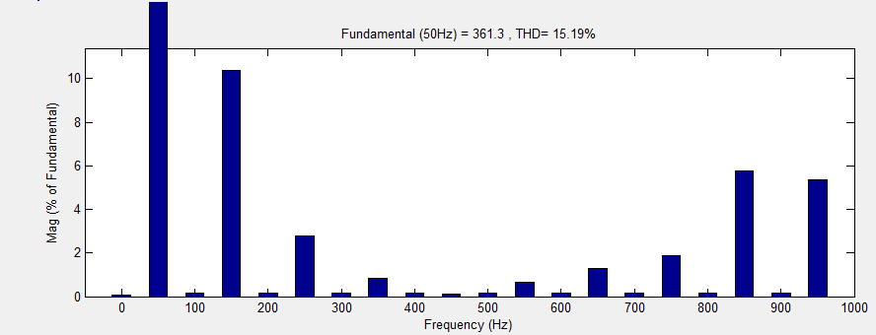

Combined Cascade Multilevel Inverter Cell
.
Discrete,
Ts = 5e-005 s.
powergui
v
+
-
Voltage Measurement
R
Scope
Repeating
Sequence3
Repeating
Sequence2
Repeating
Sequence1
Repeating
Sequence
NOT
Logical
Operator3
NOT
Logical
Operator2
NOT
Logical
Operator1
NOT
Logical
Operator
g
m
C
E
IGBT/Diode7
g
m
C
E
IGBT/Diode6
g
m
C
E
IGBT/Diode5
g
m
C
E
IGBT/Diode4
g
m
C
E
IGBT/Diode3
g
m
C
E
IGBT/Diode2
g
m
C
E
IGBT/Diode1
g
m
C
E
IGBT/Diode
DC Voltage Source1
DC Voltage Source

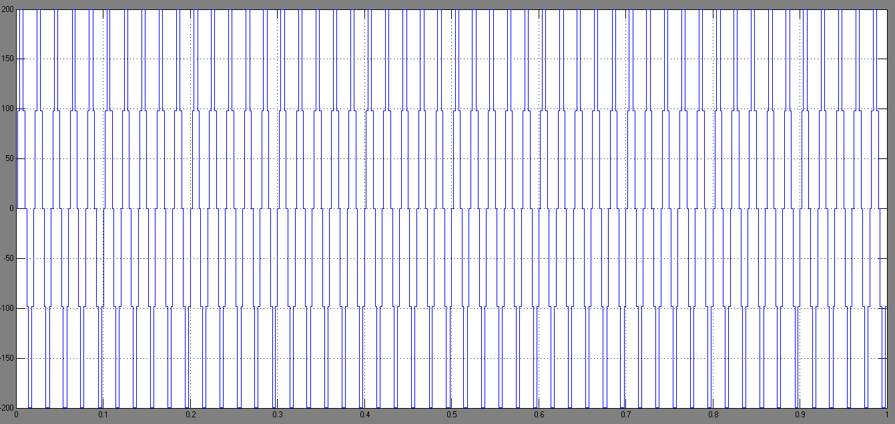

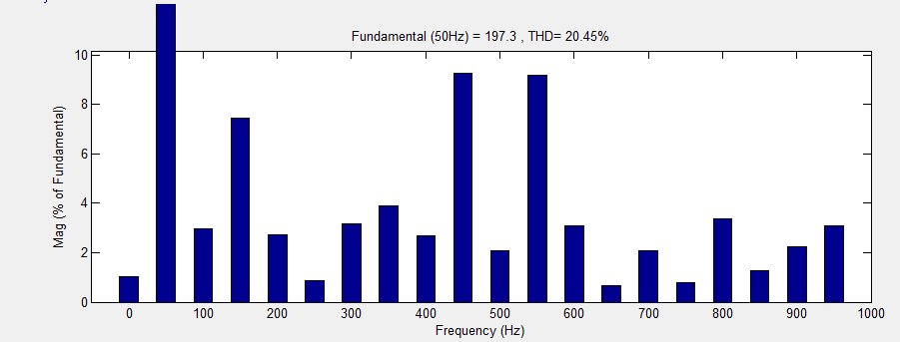

Comparison Results For Five Multilevel Inverters

Topology | Voltage Levels Number | THD | Switch Number | Separated DC Source
Cascade H-Bridge | 5 | 20.45% | 8 | 2
Incremental Cascade H-Bridge | 7 | 21.42% | 8 | 2
Incremental Cascade I-Bridge | 7 | 16.89% | 8 | 2
Incremental-Reduction Cascade H-Bridge | 9 | 15.19% | 8 | 2
Combined Cell Cascade | 25 | 20.45% | 10 | 2

6. CONCLUSION

In this paper five multilevel inverter configurations were presented and compared. The multilevel inverters were simulated in MATLAB and the comparison results proved that the combined cascade multilevel inverter had the highest number of output voltage levels due to the number of cells in cascade. Increasing the number of output voltage levels reduces the lower order harmonics and the THD. It's preferred that the output voltage has no lower order harmonics because their filtering is so hard. In the incremental cascade H-bridge in which higher DClink voltage has lower switching frequency, the number of switching devices and as a result the switching losses are reduced. The incremental cascade I-bridge structure uses a technique in which fewer switches are required so it is so affordable in comparison with the other presented structures.

REFERENCES
[1] Manjrekar,M.D.,and LIPO,T.A:’A hybrid multilevel inverter topology for drive applications,’.Proceedings of the IEEE APEC,pp.523- 529,1998.
[2] Walker, G.R.; Sernia, P.C.:’Cascaded DC-DC converter connection of photovoltaic modules’ Power Electronics Specialists Conference, pesc IEEE 33rd Annual ,vol 1,pp. 24 – 29, 2002.
[3] Fang Zheng Peng; Jih-Sheng Lai; McKeever, J.; VanCoevering, J.:’ A multilevel voltage-source inverter with separate DC sources for static VAr generation’. ,IAS '95., Conference Record of the 1995
IEEE ,vol.3.pp. 2541 – 2548,1995.
[4] Panagis, P.; Stergiopoulos, F.; Marabeas, P.; Manias, S.;’ Comparison of state of the art multilevel inverters’. IEEE, PESC ,pp. 4296 – 4301,2008.
[5] Czarkowski, L. Li, D, Liu, Y, and Pillay, P."Multilevel Selective harmonics elimination PWM technique in series-connected voltage inverter" IEEE Trans. Ind. Applicat, vol.2, PP. 1454 – 1461, 1998.
[6] Sirisukprasert. Siriroj , Jason Lai, Chair ,Dusan Borojevic ,Alex Q. Huang; "Optimized Harmonic Stepped-Waveform for Multilevel Inverter" ,. Thesis submitted to the Faculty of theVirginia Polytechnic Institute and State University, Sep.15,1999.
[7] Hosseini Aghdam, M.G.; Fathi, S.H.; Gharehpetian, G.B.; ‘Comparison of OMTHD and OHSW harmonic optimization techniques in multi-level voltage-source inverter with non-equal DC sources’. Power Electronics, ICPE '07. Pp.587-591,2007.

